**Case study: FeatureBase, Part 1: Fine tuning metrics for data collection**

In this course, you've been thinking about the stages of the business intelligence process. This case study with FeatureBase will focus on the Capture stage of the BI process, where you examine static, backward-facing data and plan for the next two phases of the project. In two follow-up case studies, you’ll learn about how FeatureBase addressed the Analyze and Monitor stages of this project. But first, you’ll need to understand the problem, process, and solutions for this first stage of the project.

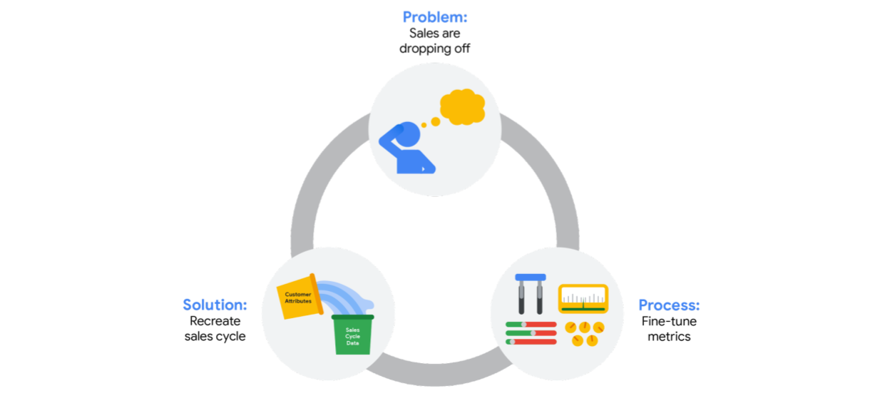

As a BI professional, you will add value to the organizations you work with. Your expertise will help organizations access the right data, use data to find ways to grow and improve, and put those insights into action. Throughout this certificate program, you will have the opportunity to explore how different businesses handled real challenges they faced using business intelligence. In this reading, you will be introduced to [FeatureBase](https://www.featurebase.com/), an Operational AI company in Austin, Texas. Across the three courses, you will encounter three case studies that follow the FeatureBase team’s approach to an actual problem they faced. This is a great example of how a real company solved a BI problem and completed an entire project–Starting with identifying a problem and preparing to tackle it!



**Company background**

FeatureBase builds technologies that unlock the value of data as soon as it is created. Based in Austin Texas, the team and community consist of database, distributed systems, and cloud engineers, as well as leading researchers on bitmap innovation. FeatureBase’s CEO, H.O. Maycotte, and founding engineers have worked for nearly 20 years to solve a gap in the database market and develop a new data format that is built specifically to enable faster computation.

Their core technology, FeatureBase, is the first OLAP Database built entirely on bitmaps that power real-time analytics and machine learning applications by simultaneously executing low latency, high throughput, and highly concurrent workloads.

**The challenge**

The sales team noticed that a significant portion of potential customers were falling off during the sales cycle. Once they discovered this pattern, they realized that they didn’t have the data they needed to really discover when customers were falling off. And if they couldn’t determine when customers were falling off, then they couldn’t find out why. And finding out why was key for creating solutions to address this problem.

**The approach**

The initial question was, “Why did we fall short on our quarterly revenue target?” To answer that question, the FeatureBase team needed to know why people dropped off and when drop-off happened. But they didn’t have the metrics built into their database to actually measure that. In order to build this question into their data collection, they had to experiment with what data was actually useful, add new attributes, and refine their metrics. For this particular project, the solution was clear: recreate their existing sales funnel with key attributes about each potential customer at every stage of the project.

To do this, the Sales leader, Marketing leader, and CEO collaborated to decide on new metrics and how to implement them within the system. It required some experimentation– the team was committed to iterating and fine tuning their data collection process in order to optimize this solution. Tuning is often a really necessary part of creating forward looking solutions; the first model is usually not the best one. It’s a first draft; you have to revise it in order to achieve the most ideal version of the solution! As a BI professional, the reality is that you might have to iterate a few times to get your model where you need it.

**The next step**

As a BI professional, there will be times when you are asked a question that you don’t have sufficient data to actually answer. Sometimes, you have to keep digging, keep researching, and keep thinking about how to provide an insightful answer your team can actually use. In this case, the FeatureBase team realized they had observed that there was a trend, but they couldn’t determine what it was and how to act on it with the data they had. The first step was deciding what metrics they could implement to actually capture useful observations. As a team, they collaborated and fine tuned their data collection processes. Coming up in the next course, you’ll learn more about how they actually imposed these new processes on their database systems, what tools they used, and how that set them up for success.

If you’re interested in reading more about FeatureBase’s approach to answering this question, you can find more in the FeatureBase [part two](https://www.coursera.org/learn/the-path-to-insights-data-models-and-pipelines/supplement/kq602/) and [part three](https://www.coursera.org/learn/decisions-decisions-dashboards-and-reports/supplement/7E7D5/case-study-featurebase-part-three-exploring-the-trends-with-visualizations) readings featured in upcoming courses.